PROJECT REPORT

**“ManageX:”**

*An app for Company Management and Sales Analysis*

(Using Python, tkinter, MySQL, Pandas and Matplotlib)

**Submitted By:**

*Bharat Pant*

*J.C. BOSE UNIVERSITY OF SCIENCE AND TECHNOLOGY*

**DECLARATION FROM STUDENT**

I**, BHARAT PANT** hereby declare that project report on, **“ManageX: An app for Company Management and Sales Analysis”** (Using Python, tkinter, MySQL, Pandas and Matplotlib), which is being submitted in partial fulfillment for the certificate of Industrial training, is the record of authentic work carried out by **BHARAT PANT** during the period **from 20th May 2020 to 3rd July 2020** under the guidance of **Ms. Jyoti Mehra** and **Mr. Rohan Kumar.**

I hereby declare that this project work has not been submitted before or for any other purpose.

*This is to certify that the above statement made by the candidate is correct to the best of my knowledge.*

**Signature:**

**BHARAT PANT**

**J.C. BOSE UNIVERSITY OF SCIENCE AND TECHNOLOGY**

**Under the mentorship of:**

**Ms. Jyoti Mehra**

**(Mentor)**

**Mr. Rohan Kumar**

**(Co-Mentor)**

**ACKNOWLEDGEMENT**

I, **BHARAT PANT** is using this opportunity to express our gratitude to everyone who supported us throughout the course of this project. I am thankful for their aspiring guidance, invaluably constructive criticism and friendly advice during the project work. I am sincerely grateful to them for sharing their truthful and illuminating views on a number of issues related to the project.

I express my warm thanks to my mentor **Ms. Jyoti Mehra** and my co-mentor **Mr. Rohan Kumar** for their constant support and guidance.

It certainly was a big learning curve for us. Even though I did face many difficulties ultimately the careful planning and the dedication by which I was able to complete all the work. In the documentary I try and list the complete process that went into making the text pad into complete structure.

Thank you,

**BHARAT PANT**

**TABLE OF CONTENT**

|  |  |
| --- | --- |
| Topic | Page Number |
| 1. Abstract  1.1 About Python  1.2 Sources of Python | 4  4 |
| 2. Requirement Specification  2.1 Hardware Requirements  2.2 Software Requirements | 4  4 |
| 3. Introduction  3.1 Python  3.2 tkinter  3.3 Matplotlib  3.4 Pandas  3.5 MySQL | 5  5  5  5  5 |
| 4. About Project | 6-15 |
| 5. References | 16 |

**ABSTRACT**

PYTHON:

In technical terms, Python is an object-oriented, high-level programming language with integrated dynamic semantics primarily for web and app development. It is extremely attractive in the field of Rapid Application Development because it offers dynamic typing and dynamic binding options.

The concept of a “scripting language” has changed considerably since its inception, because Python is now used to write large, commercial style applications, instead of just banal ones.

This reliance on Python has grown even more so as the internet gained popularity. A large majority of web applications and platforms rely on Python, including Google’s search engine, YouTube, and the web-oriented transaction system of the New York Stock Exchange (NYSE). You know the language must be pretty serious when it’s powering a stock exchange system.

Additionally, Python supports the use of modules and packages, which means that programs can be designed in a modular style and code can be reused across a variety of projects.

SOURCES OF PYTHON:

Open Source Python 3.8

Jet Brains PyCharm

**REQUIREMENT SPECIFICATION**

HARDWARE REQUIREMENTS:

* Processor Intel i5 8th Gen
* Processor Speed 1.8 Ghz
* RAM 8 GB
* Hard Disk 2 TB

SOFTWARE REQUIREMENTS:

* Operating System Windows 10
* Software Python, tkinter, pandas, matplotlib, MySQL

**INTRODUCTION**

PYTHON:

**Python** is an [interpreted](https://en.wikipedia.org/wiki/Interpreted_language), [high-level](https://en.wikipedia.org/wiki/High-level_programming_language), [general-purpose](https://en.wikipedia.org/wiki/General-purpose_programming_language) [programming language](https://en.wikipedia.org/wiki/Programming_language). Created by [Guido van Rossum](https://en.wikipedia.org/wiki/Guido_van_Rossum) and first released in 1991, Python's design philosophy emphasizes [code readability](https://en.wikipedia.org/wiki/Code_readability) with its notable use of [significant whitespace](https://en.wikipedia.org/wiki/Off-side_rule). Its [language constructs](https://en.wikipedia.org/wiki/Language_construct) and [object-oriented](https://en.wikipedia.org/wiki/Object-oriented_programming) approach aim to help [programmers](https://en.wikipedia.org/wiki/Programmers) write clear, logical code for small and large-scale projects.

Python is [dynamically typed](https://en.wikipedia.org/wiki/Dynamic_programming_language) and [garbage-collected](https://en.wikipedia.org/wiki/Garbage_collection_(computer_science)). It supports multiple [programming paradigms](https://en.wikipedia.org/wiki/Programming_paradigms), including [structured](https://en.wikipedia.org/wiki/Structured_programming) (particularly, [procedural](https://en.wikipedia.org/wiki/Procedural_programming)), [object-oriented](https://en.wikipedia.org/wiki/Object-oriented_programming), and [functional programming](https://en.wikipedia.org/wiki/Functional_programming). Python is often described as a “complete” language due to its comprehensive [standard library](https://en.wikipedia.org/wiki/Standard_library).

Tkinter:

Python offers multiple options for developing GUI (Graphical User Interface). Out of all the GUI methods, tkinter is the most commonly used method. It is a standard Python interface to the Tk GUI toolkit shipped with Python. Python with tkinter is the fastest and easiest way to create the GUI applications.

PANDAS:

Pandas is an open-source, BSD-licensed Python library providing high-performance, easy-to-use data structures and data analysis tools for the Python programming language. Python with Pandas is used in a wide range of fields including academic and commercial domains including finance, economics, Statistics, analytics, etc. In this tutorial, we will learn the various features of Python Pandas and how to use them in practice.

MATPLOTLIB:

**Matplotlib** is a [plotting](https://en.wikipedia.org/wiki/Plotter) [library](https://en.wikipedia.org/wiki/Library_(computer_science)) for the [Python](https://en.wikipedia.org/wiki/Python_(programming_language)) programming language and its numerical mathematics extension [NumPy](https://en.wikipedia.org/wiki/NumPy). It provides an [object-oriented](https://en.wikipedia.org/wiki/Object-oriented_programming) [API](https://en.wikipedia.org/wiki/API) for embedding plots into applications using general-purpose [GUI toolkits](https://en.wikipedia.org/wiki/GUI_toolkit) like [Tkinter](https://en.wikipedia.org/wiki/Tkinter" \o "Tkinter), [wxPython](https://en.wikipedia.org/wiki/WxPython" \o "WxPython), [Qt](https://en.wikipedia.org/wiki/Qt_(software)), or [GTK+](https://en.wikipedia.org/wiki/GTK%2B). There is also a [procedural](https://en.wikipedia.org/wiki/Procedural_programming) "pylab" interface based on a [state machine](https://en.wikipedia.org/wiki/State_machine) (like [OpenGL](https://en.wikipedia.org/wiki/OpenGL)). With matplotlib we are able to graphically present the data so that it may be understood easily.

MySQL:

MySQL is an open-source relational database management system (RDBMS). A relational database organizes data into one or more data tables in which data types may be related to each other; these relations help structure the data. SQL is a language programmer use to create, modify and extract data from the relational database, as well as control user access to the database. In addition to relational databases and SQL, an RDBMS like MySQL works with an [operating system](https://en.wikipedia.org/wiki/Operating_system) to implement a relational database in a computer's storage system, manages users, allows for network access and facilitates testing database integrity and creation of backups

**ABOUT PROJECT**

**BRIEF:**

ManageX: An App for Company Management and Sales Analysis is a desktop application build using Python programming language incorporated with Graphical User Interface (GUI) using tkinter module of the Python package. ManageX is capable to handle records for a company since it is using MySQL database at the backend. The complete information of the company like the employee record, attendance record, billing for customer, stuff sold and purchased etc. is thus stored at the backend in the database. Further this app is capable to analyse the sales which the company has done so far, in order to provide the manager and the higher authority with the knowledge of how the company is actually performing in the field of selling its product. The complete data analysis is performed using the Pandas module and is visualized using the graph plotting module Matlplotlib to provide best experience to the user of this application.

In the next section the complete functioning and all specifications of the of the app are depicted by means of actual application interface screenshots.

**PROJECT DESCRIPTION:**

LOGIN PAGE:

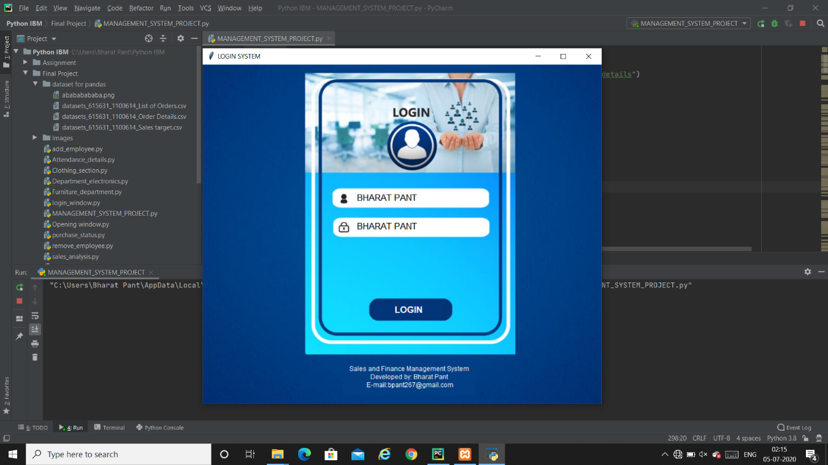

The app opens with the login page asking user to log in to the account. In the beginning since no data regarding employee is present in the database, a global Admin can access the features using the global ID: “BHARAT PANT” and Password “BHARAT PANT”.

However once data regarding employee is entered they can access the respective departments which are alloted to them.

EDIT EMPLOYEE PAGE:

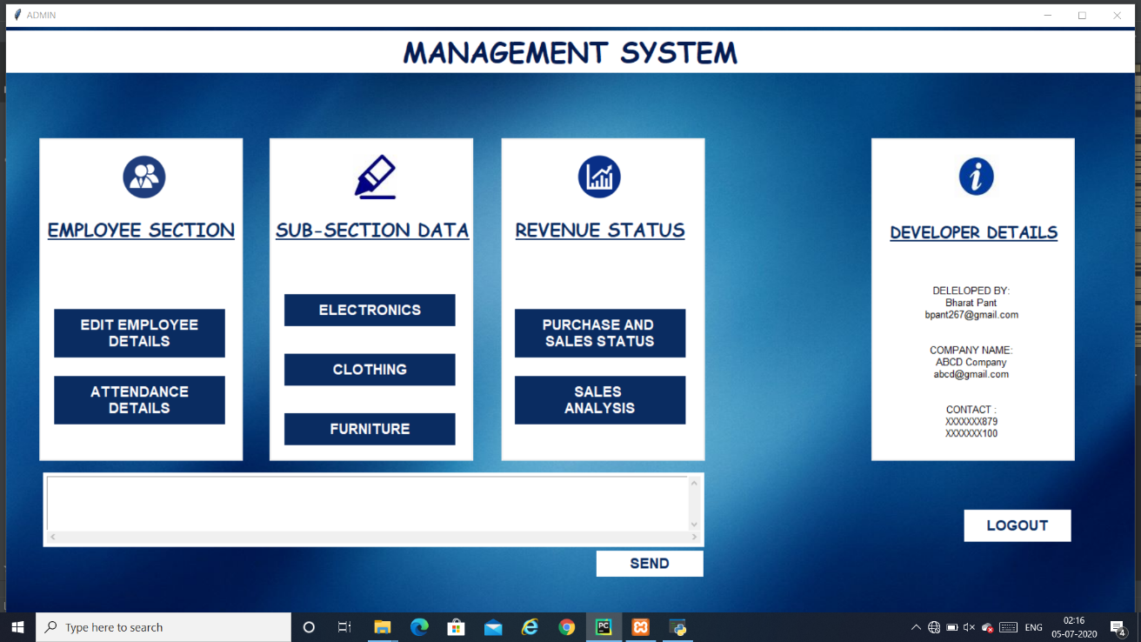

Once login is done then the main page of the application apperars, this page appears to only those who are having admin access to this application. This section comprises of access to all the departments inclusing finance and sales analysis section. This window comprises of 7 section namely:

* EMPLOYEE SECTION

1. EDIT EMPLOYEE DETAILS
2. ATTENDANCE DETAILS

* SUB-SECTION DATA

1. ELECTRONICS
2. CLOTHING
3. FURNITURE

* REVENUE STATUS

1. SALES AND PURCHASE STATUS
2. SALES ANALYSIS

These sections can directly be accessed by clicking on the respective buttons.

The textbox at the botyom is used to store important notes for higher authority and by clicking “Send” button the information is stored at the backend.

EMPLOYEE SECTION:

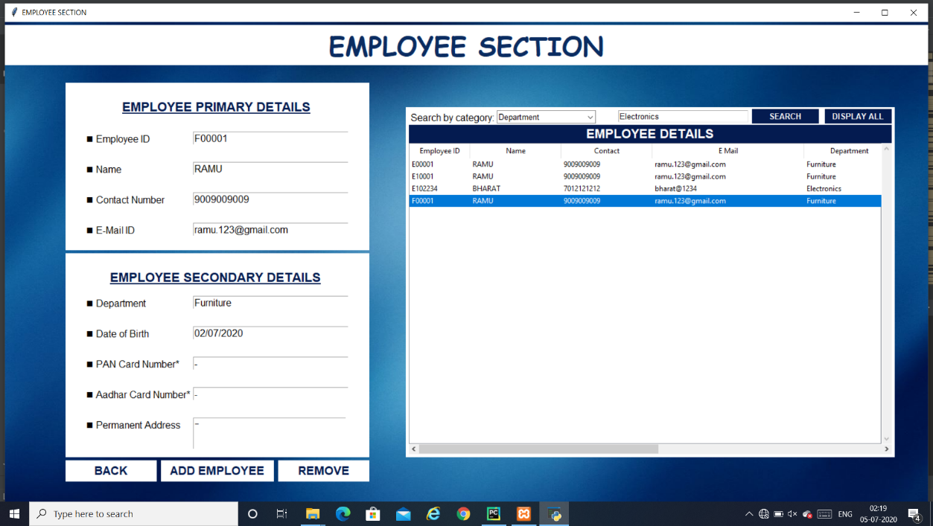

In the Edit Employee page the admin is able to add,remove or update the employee details by clicking on the respective buttons. The admin too can search for the specific person on the basis of category in order to fetch details of the employee.

Once the employee is added, depending upon the ID alloted to him/her and the details entered in the details column, a unique login ID and password is generated where login ID is Employee ID and password is “Year_of_birth@last_four_digits_of_contact_number”.

Due to the validations every employee would be getting a unique ID otherwise no entry would be performed.

*The ID must comprise of “E”, ”C” and “F” as first letter of Employee ID to allow access to respective sections i.e. Electronics, Clothing and Furniture.*

Depending upon the ID alloted the syatem would automatcally direct that employee to their respective department pages.

ELECTRONICS SECTION:

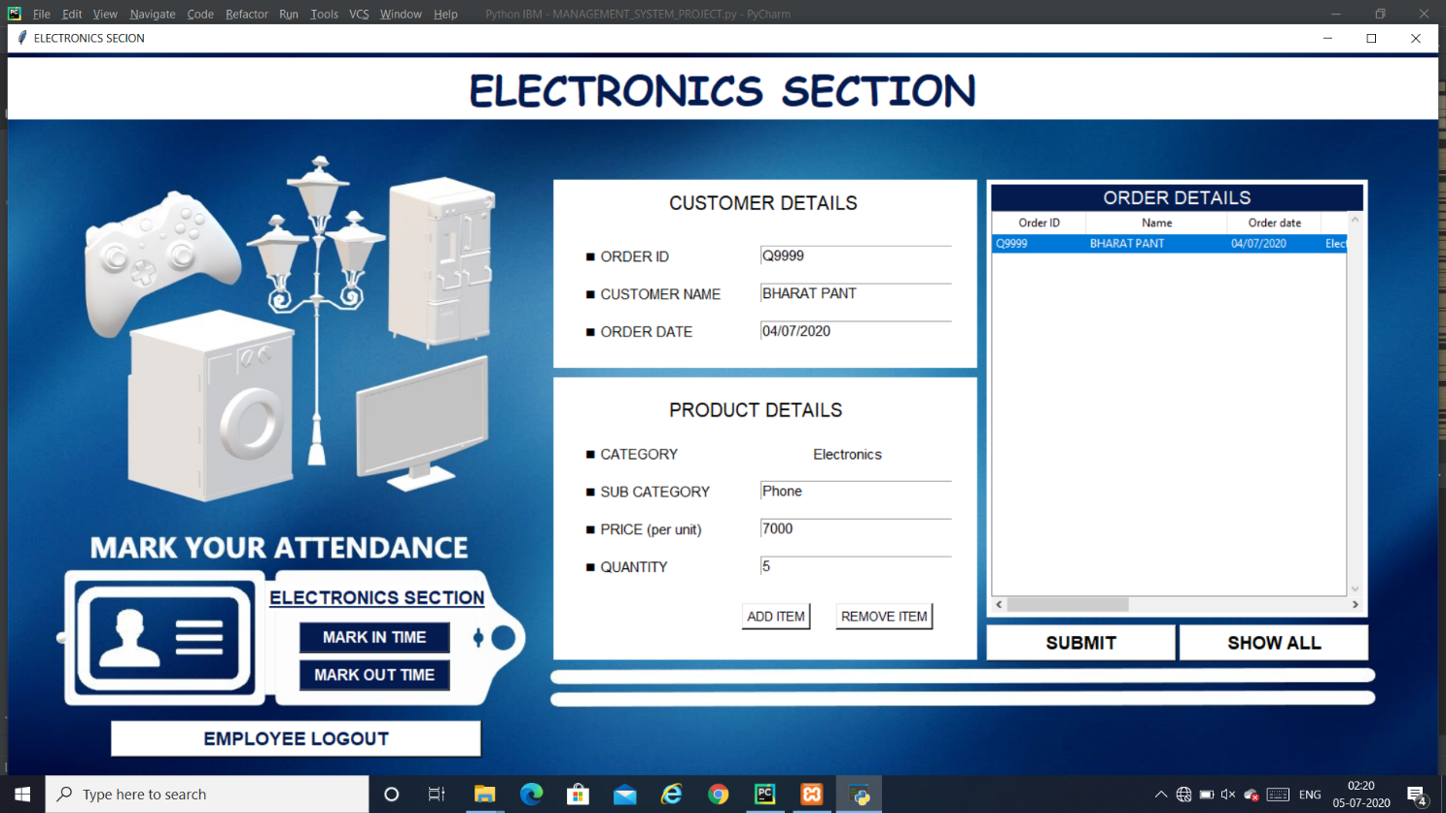

This page is accesible to only the employees who are alloted the Electronics department along with the admin rest no one could access this page. This page comprises of Marking attendance by means of providing IN time and OUT time to calculate the duration of the work hous. Further this section is incorported with the billing system where the employee enters the product details and basd on the purchase of customer the bill is generated. The complete bill details and purchase details are stored in the database at the backend. The Employee could perform the functions of adding or removing the product as depicted on the respective buttons. Submit button stores the complete information in the database.

Same valisdation as eariler are provided here also making the system pop up error message when two different users would be having same ORDER ID.

The same functionality is performed in the other two sections i.e.

* Clothing Section
* Furniture Section

However the order ID can’t be same even for the two other departments

The snapshots of the two sections i.e. Clothing section and Furniture Section are listed below:

CLOTHING SECTION:

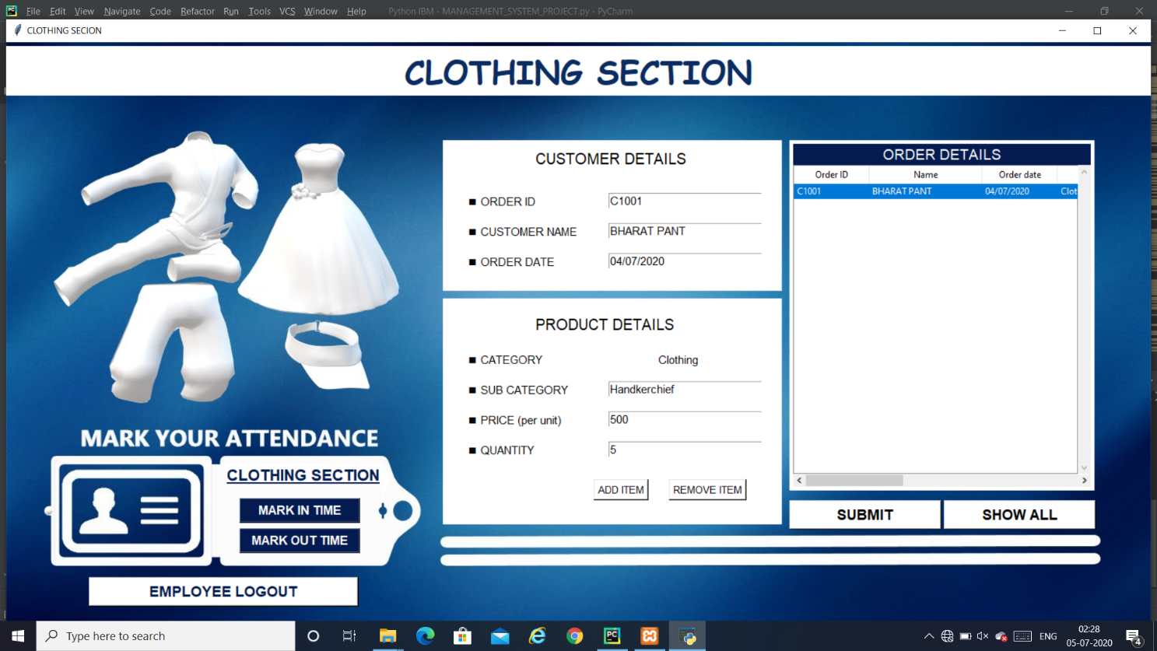

FURNITURE SECTION:

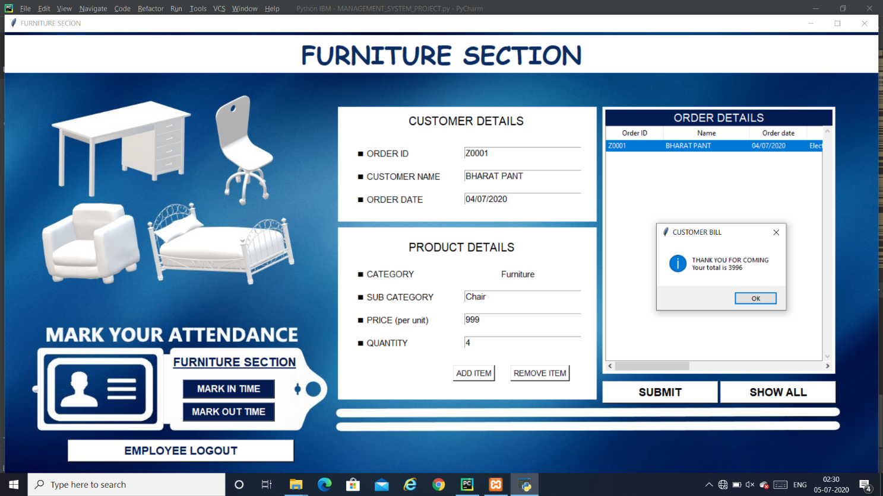

FINANCE SECTION:

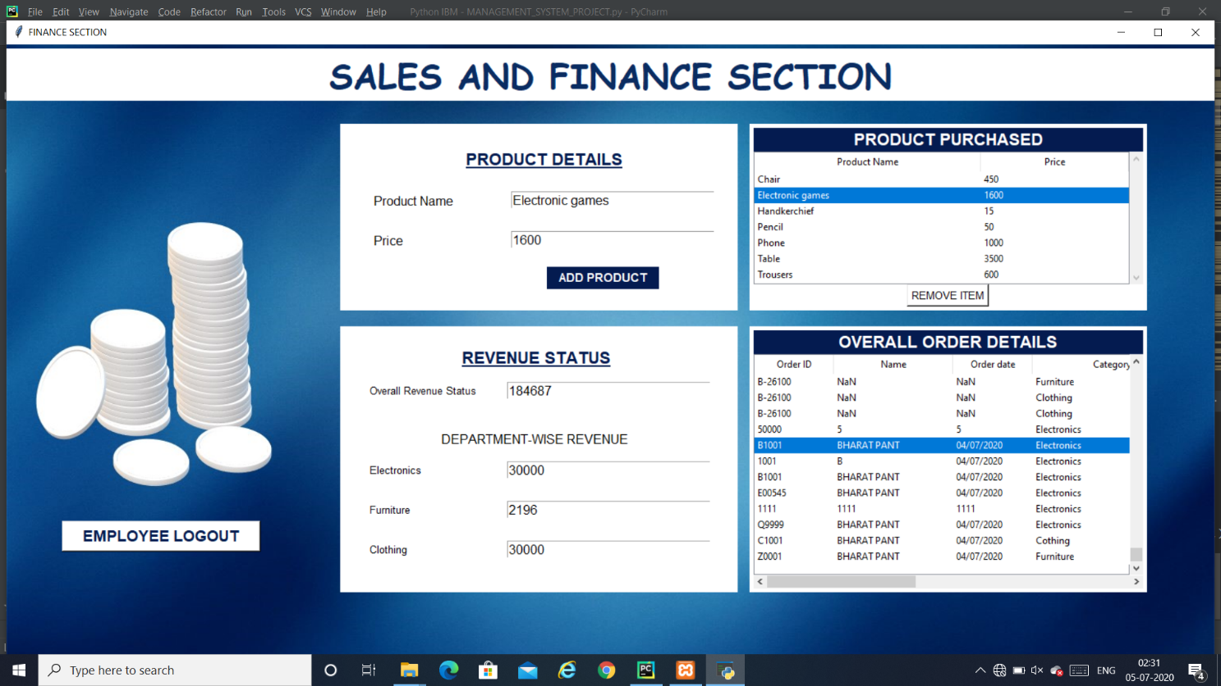

This page is also accessible only to admin and only finance section. In this page we can add the product and its details which are currently in stock. The product details are entered here in advance which gets stored in the database which then further is used by the department sections to fetch the MRP of product in order to gain profit or loss status. The revenue status displays the overall revenue generated by different department. The overall order detail displays the order received till date. Data set for sales is picked up from Kaggle which is then added to the database.

For the new records, the data is appended at the end of the database.

SALES ANALYSIS PAGE:

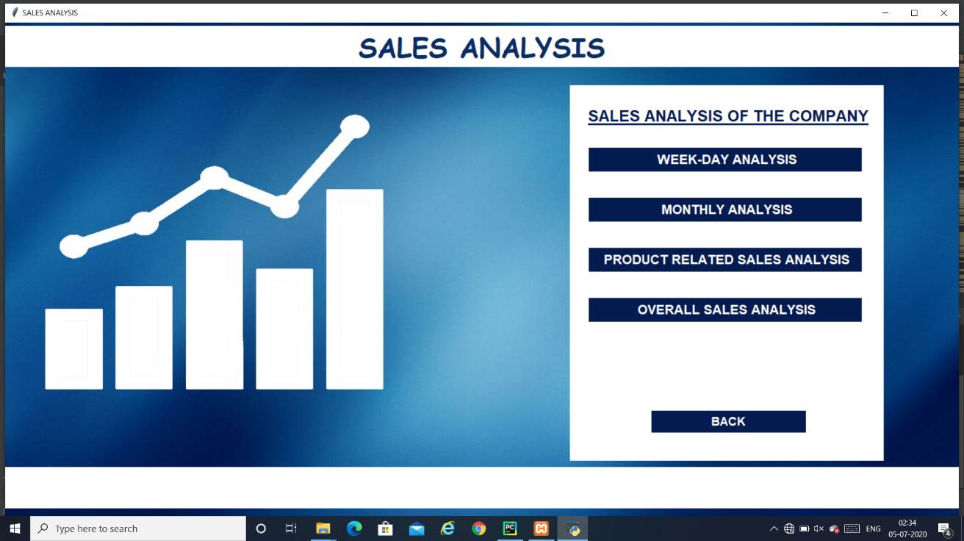

This page allows admin to access the analysis performed on the data of revenue generated by the company. This section depicts the analysis performed on 4 factors like:

* Weekday analysis
* Monthly analysis
* Product Related Sales Analysis
* Overall Sales Analysis

For this section the dataset from KAGGLE was considered and was assumed to be the earlier record for the company. For the fresh data entered it would be appended at the end of the earlier dataset.

The pic of dataset used is attached here :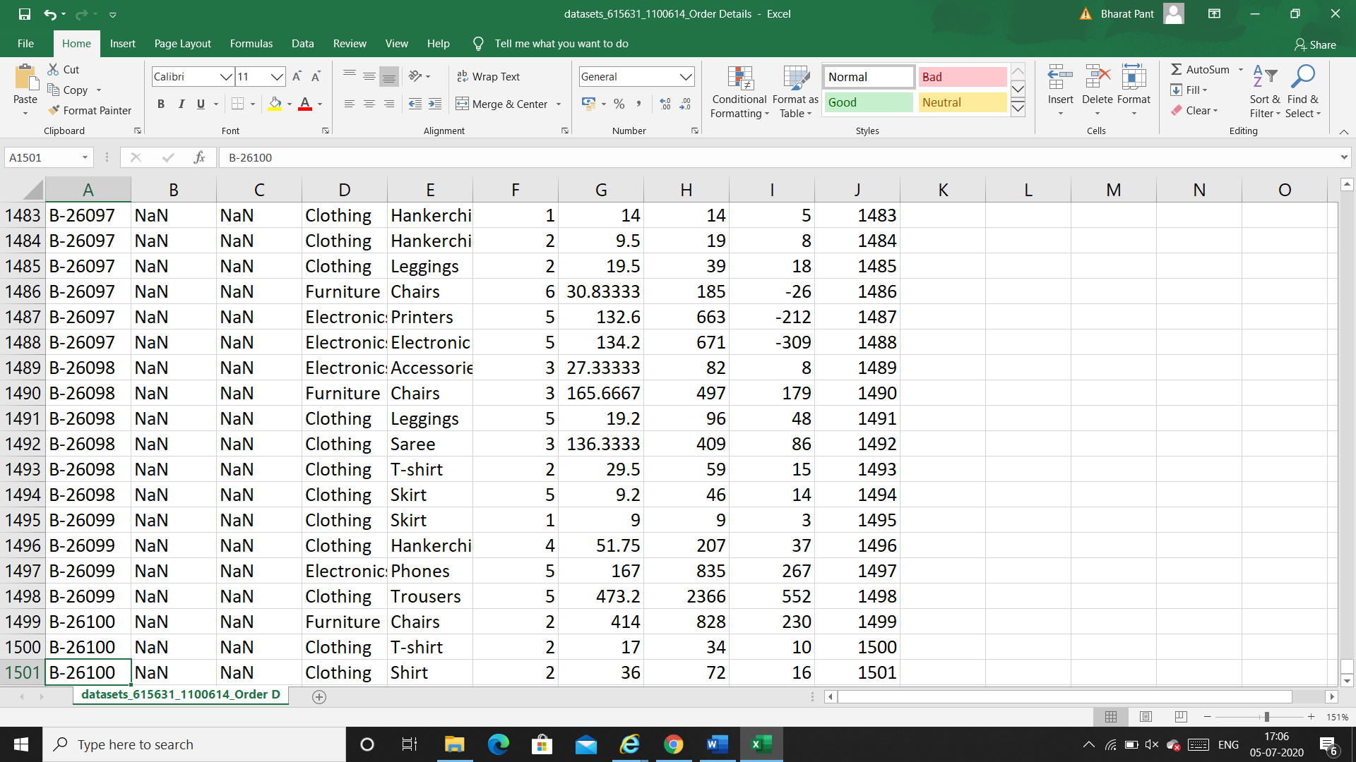

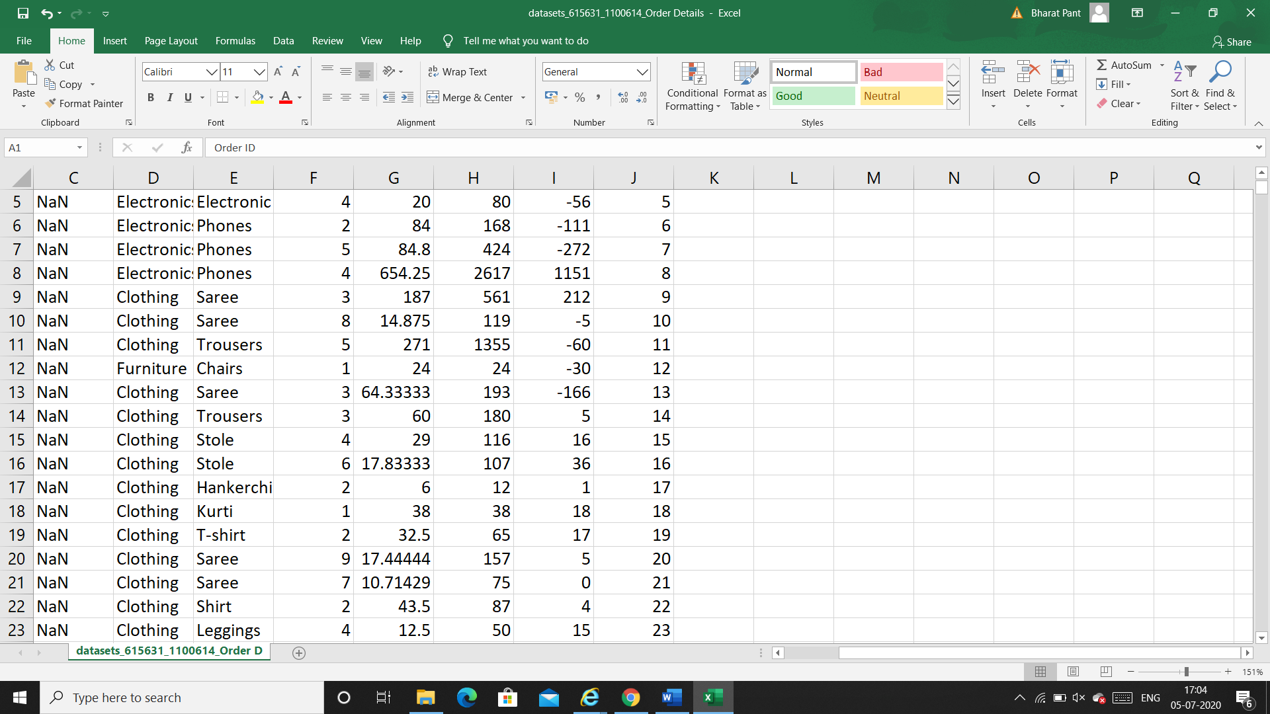

The analysis is thus performed on the above dataset along with the fresh data being appended and thus analysis updates after every new entry made in he order details.

The results of the analysis are shown as below:

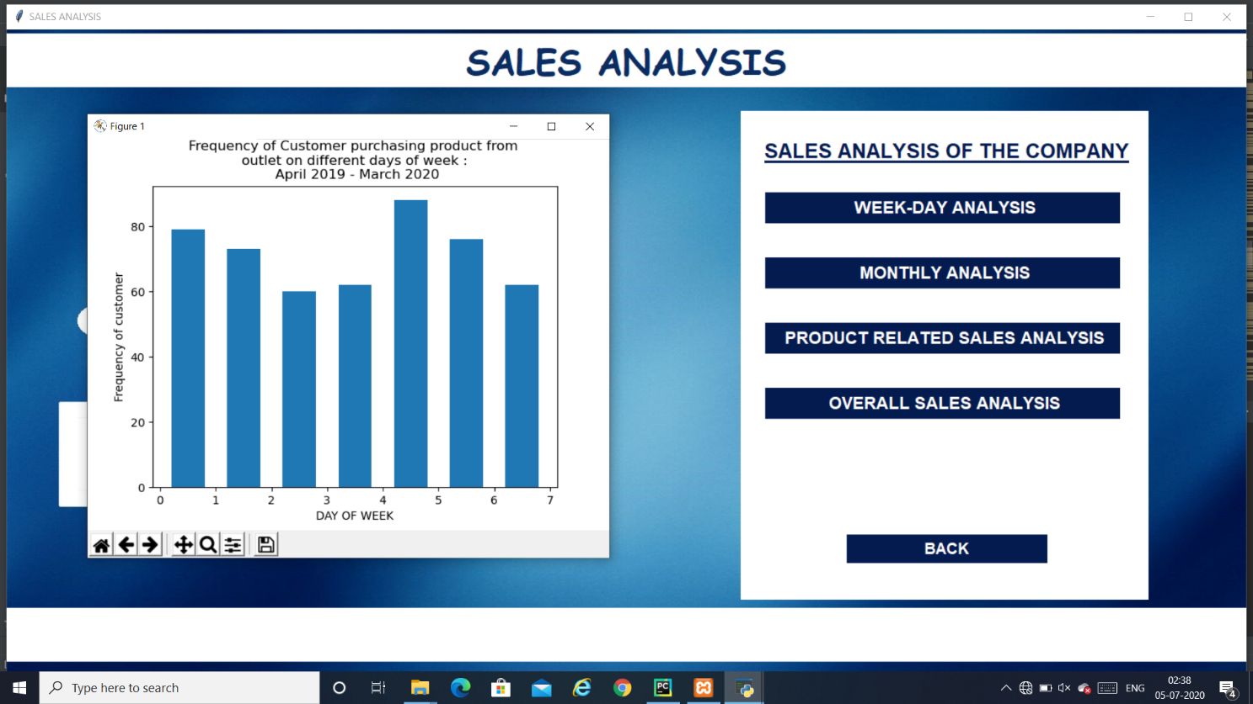

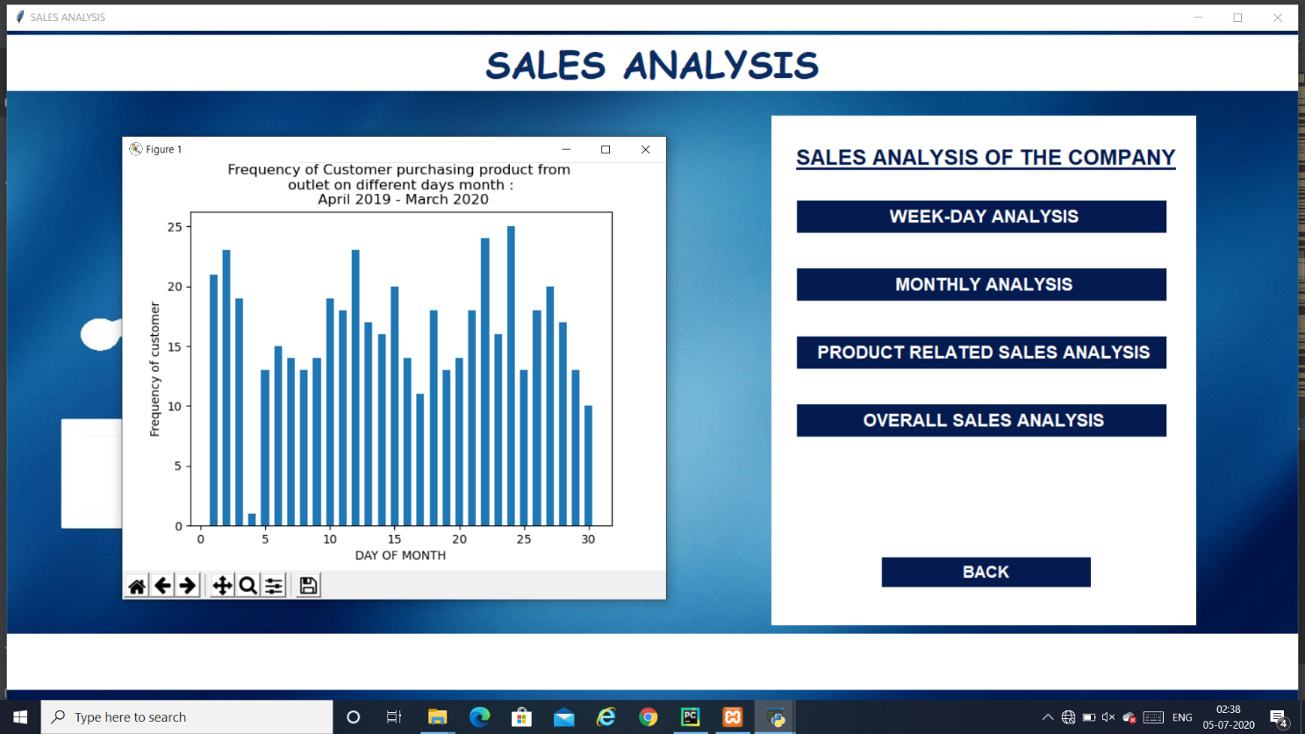

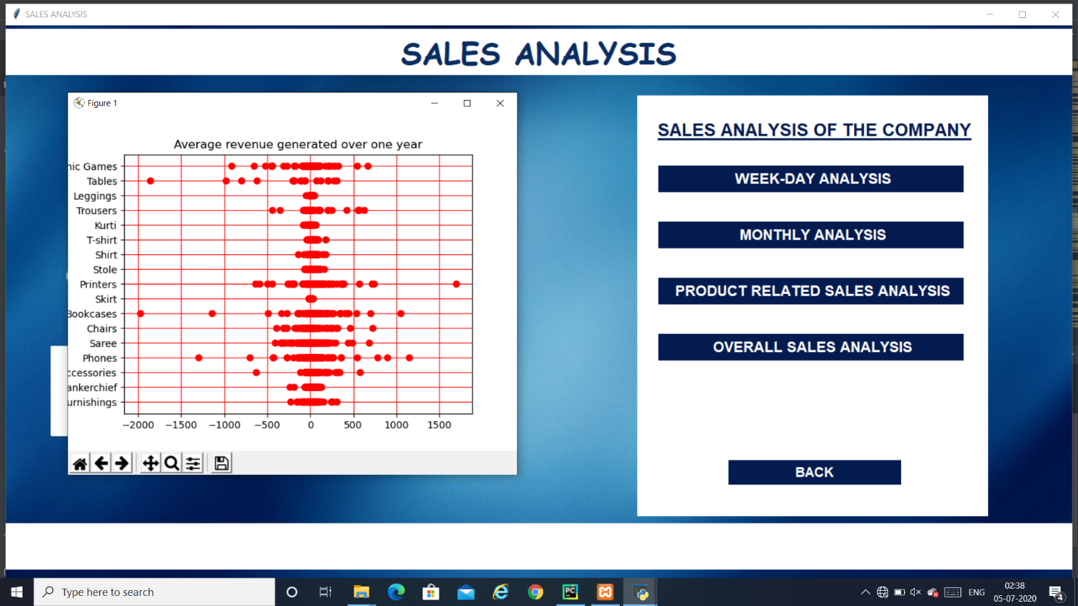

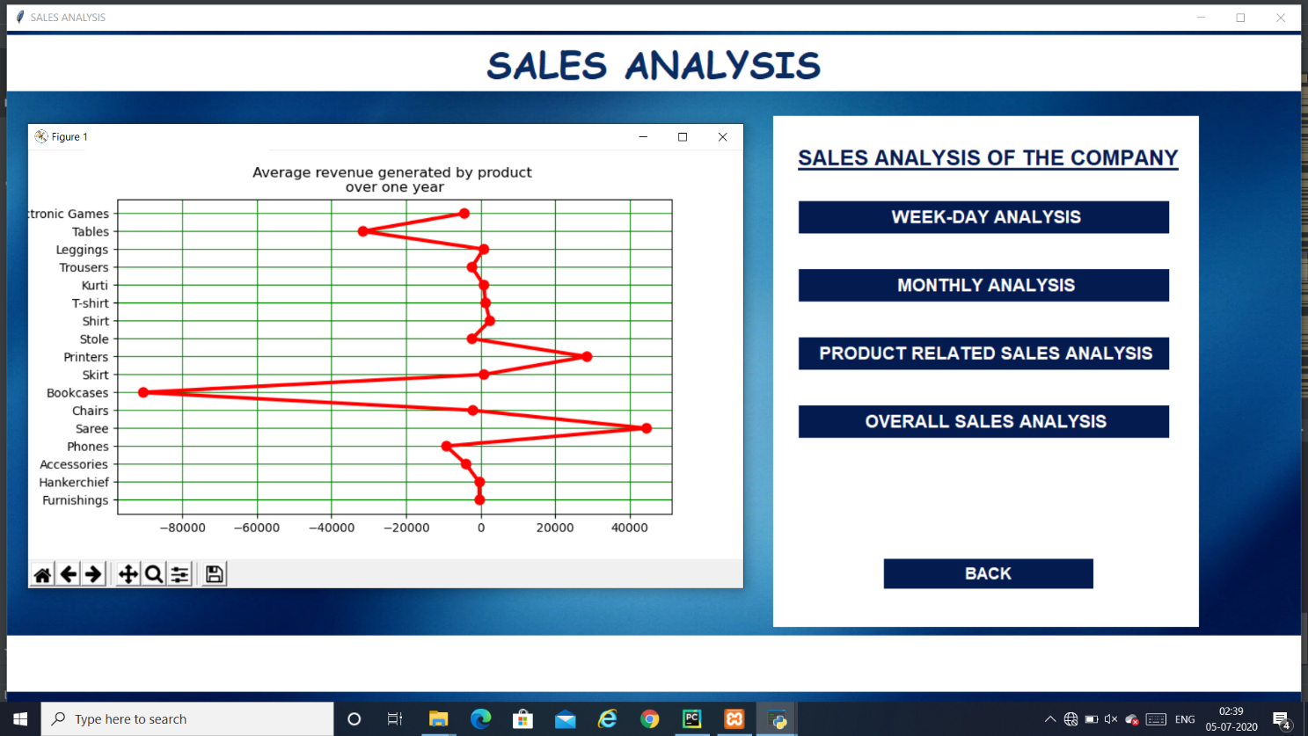

The above analysis helps us to get know about the following things:

* Status of the company
* Number of orders done on weekly basis
* Number of order done on monthly basis
* Profit or loss experienced per product which compant sells
* Overall profit or loss generated due to that perticular item

ATTENDANCE RECORDS:

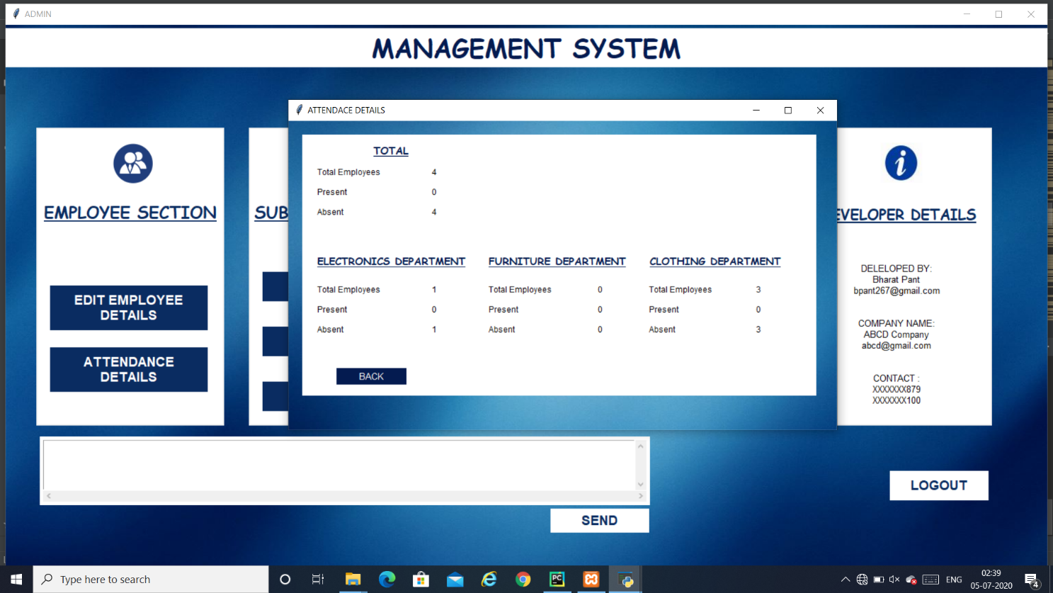

The attendance recorrd page is accessible to only admin which allows him/her to have a look on the number of employees present and absent on that particular day.

The data is stored in the database permenantly and updates on the screen on daily basis. Due to the validation it is designed to provide a full day present when the work hours are greater than 7.

The attendance updates with the losin and MARK IN and MARK OUT time entered by the employee as mentioned earlier.

VALIDATIONS:

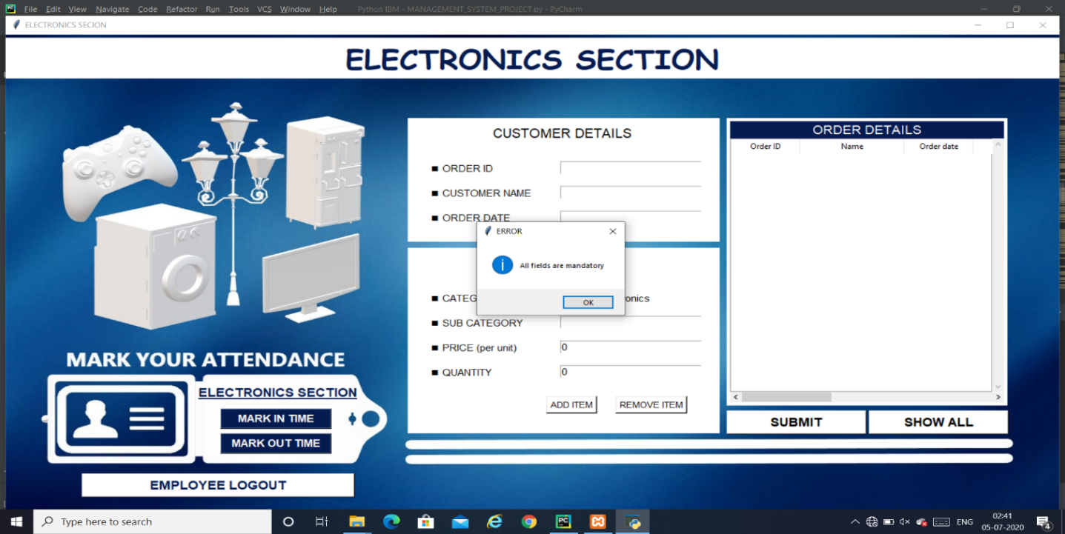

The complete system is put under validation where ever possible to prevent false data entry into the database. A snapshot of such validation is mentioned above.

BIBLIOGRAPHY:

I have taken the dataset from various websites which has helped me to update my app database with the best possible data of a company’s sales and finance section.

Links:

<https://www.kaggle.com>

<https://www.apache.org>

https//:www.jetbrains.org